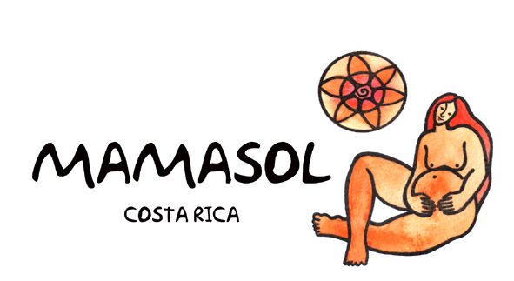
Mamasol Internship Application:
Experience for Students Interested in Midwifery and Global Women’s Health

Contact Information

Name: Birth Date: (mm/dd/yy)
(First) (Last) (MI)

Street Address:
(Street) (City) (Zip)

Contact Phone #: ( ) Email address:

Education

Name of school or organization: Year:

Major(s): Minor(s):

Relevant experience:

Travel Experience: ___________________________________________________________________________________
_________________________________________________________________________________________________________

Spanish Proficiency: __________________________________________________________________________________

Emergency Contact Info

1) Name: Relationship:

Cell Phone: ( ) Home Phone: ( )

2) Name: Relationship:

Cell Phone: ( ) Home Phone: ( )

Health issues: _______________________________________________________________________________________
More about yourself!

- Why are you interested in this internship?

- What do you hope to accomplish during this internship? (ideas you have/personal goals/etc.)

- What are some of your personal strengths, and areas for growth?

- What are your future career/life goals and how do you plan to apply this experience to those goals?

- Other interests/things you want to do while here in Turrialba / Costa Rica?

- What dates would you prefer to come?

Mamasol Internship Information

About the Internship

This is an internship for those interested in midwifery, global women’s health, and activism for women’s empowerment. During the internship, the student will gain perspective about women’s health and maternity issues in Costa Rica, and the challenges we face in a traditionally “machista” culture and paternalistic health care system, which have systematically pathologized and appropriated women’s bodies and reproductive processes. By working alongside the Mamasol midwives and other complementary care providers, the intern will have a chance to observe, participate in, and even create services that actively promote a more respectful, holistic, empowering model of care for women. The intern will live at the newly-created Mamasol Center in Turrialba, taking part in all the classes and workshops offered to the community, in addition to shadowing Dr. Rebecca Turecky, an experienced midwife in the area. The internship provides hands-on experience of what holistic therapeutic care for pregnant mothers and babies looks like in the form of classes such as prenatal yoga, meditation, and baby massage therapy. Interns will gain awareness about the natural birth process and the personalized, supportive midwifery model of care by sitting in on prenatal visits and homebirths with Rebecca’s clients, and even visiting a 95-year-old traditional Costa Rican midwife! Each intern is welcome to assist in teaching, writing or developing new programs that contribute to Mamasol’s goals and efficacy.

About Mamasol

Mamasol is a non-profit organization created to promote the humanization of childbirth in Costa Rica. Our mission is to promote women’s whole health and self-determination, and to support all women, babies, and families in achieving a safe, satisfying, dignified birth, free of violence and coercion, and full of love and respect!

About the Supervisor

Dr. Rebecca Turecky has been working in the field of Women's Health and Midwifery for 30 years, with experience in the United States, Europe, Africa, and Costa Rica. She has resided in Turrialba for 25 years, and co-founded the Mamasol Association in the year 2000. She received her Bachelor's degree (BA) in Women's Studies from the University of California, Santa Cruz, her Doctorate of Nursing (ND) from the University of Colorado Health Sciences Center, and her Certificate in Nurse-Midwifery (CNM) from the Frontier School of Midwifery and Family Nursing in the United States. Subsequently, she received her Bachelor of Nursing and her Masters in Gynecological, Obstetric and Perinatal Nursing from the University of Costa Rica. She is licensed to practice by the American College of Nurse-Midwives and the College of Nurses of Costa Rica.

Mamasol Activities

- Education and women’s empowerment through lectures, workshops, support groups
- Production of written materials, documentaries, and the creation and management of a website (www.mamasol.com) and facebook page with free access to pregnancy and childbirth information
- Public advocacy, collaboration and consulting with the CCSS maternity health care system, the University of Costa Rica, governmental offices and other NGOs
- Doula training courses and Respectful Childbirth conferences annually
- Childbirth preparation courses, prenatal yoga, holistic prenatal care, homebirth and waterbirth services, parenting and lactation consults, early childhood development
- Adolescent women’s support groups, sexuality education

Schedule

Internships may be arranged on a monthly basis, with a minimum 2-month stay recommended. Mamasol is typically available to accept interns any time between January-June and August-December. The midwives take off July every year for vacation. Work and study hours will sometimes vary—due to the unpredictable timing of birth—but will average 30-40 hours a week.

Language

Ideally, the intern is proficient in Spanish, since most of our clients, activities and materials are en español! If not, we can help arrange intensive Spanish language classes as part of the internship as well (additional cost).

Housing

Interns will live in a homestay arrangement, sharing daily life with a local family. This can range from a fairly independent situation (apartment-style) to multi-generational family accommodations, with shared meals, bathrooms, etc.

Turrialba is a typical Costa Rican town, with incredible natural surroundings and tourist opportunities, such as river rafting, zipline, horseback, waterfalls, volcano and the Guayabo national archeological site. It is a 2-hour bus ride to San Jose, where we participate in many other activities weekly. The Caribbean coast is 2 hours to the east.

